1. Create a new react application using *create-react-app* tool with the name as “blogapp”
2. Open the application using VS Code
3. Create a new file named as **Post.js** in **src folder** with following properties
4. Initialize the component with a list of Post in state of the component using the constructor
5. Create a new method in component with the name as **loadPosts()** which will be responsible for using Fetch API and assign it to the component state created earlier. To get the posts use the url (<https://jsonplaceholder.typicode.com/posts>)
6. Implement the **componentDidMount()** hook to make calls to **loadPosts()** which will fetch the posts
7. Implement the **render()** which will display the title and post of posts in html page using heading and paragraphs respectively.
8. Define a **componentDidCatch()** method which will be responsible for displaying any error happing in the component as alert messages.
9. Add the Posts component to App component.
10. Build and Run the application using *npm start* command.

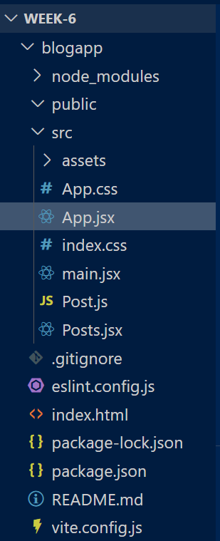  
  
  
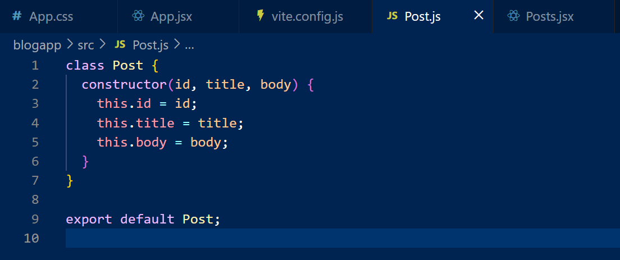

**Posts.jsx:**

import React from "react";

import Post from "./Post";

class Posts extends React.Component {

  constructor(props) {

    super(props);

    this.state = {

      posts: [],

    };

  }

  loadPosts() {

    fetch("https://jsonplaceholder.typicode.com/posts")

      .then((response) => response.json())

      .then((data) => {

        const postObjects = data.map(

          (item) => new Post(item.id, item.title, item.body)

        );

        this.setState({ posts: postObjects });

      })

      .catch((error) => {

        console.error("Error fetching posts:", error);

        alert("Error fetching posts.");

      });

  }

  componentDidMount() {

    this.loadPosts();

  }

  componentDidCatch(error, info) {

    console.error("Caught error:", error, info);

    alert("An error occurred in Posts component.");

  }

  render() {

    return (

      <div>

        <h1>Blog Posts</h1>

        {this.state.posts.map((post) => (

          <div key={post.id}>

            <h2>{post.title}</h2>

            <p>{post.body}</p>

          </div>

        ))}

      </div>

    );

  }

}

export default Posts;

